Products

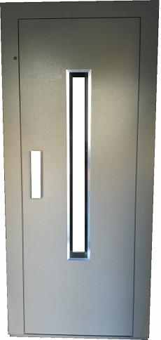 | 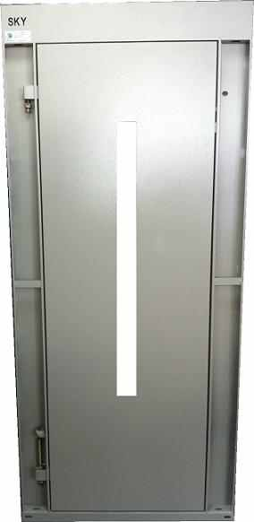
Sky-01
Spacial hand rail and frame design
120 degree openning stell hinges
High bearing capacity with special screwed steel hing system
Full support and longitudinal bracing system in door flaps
Easy assembly, working without problems

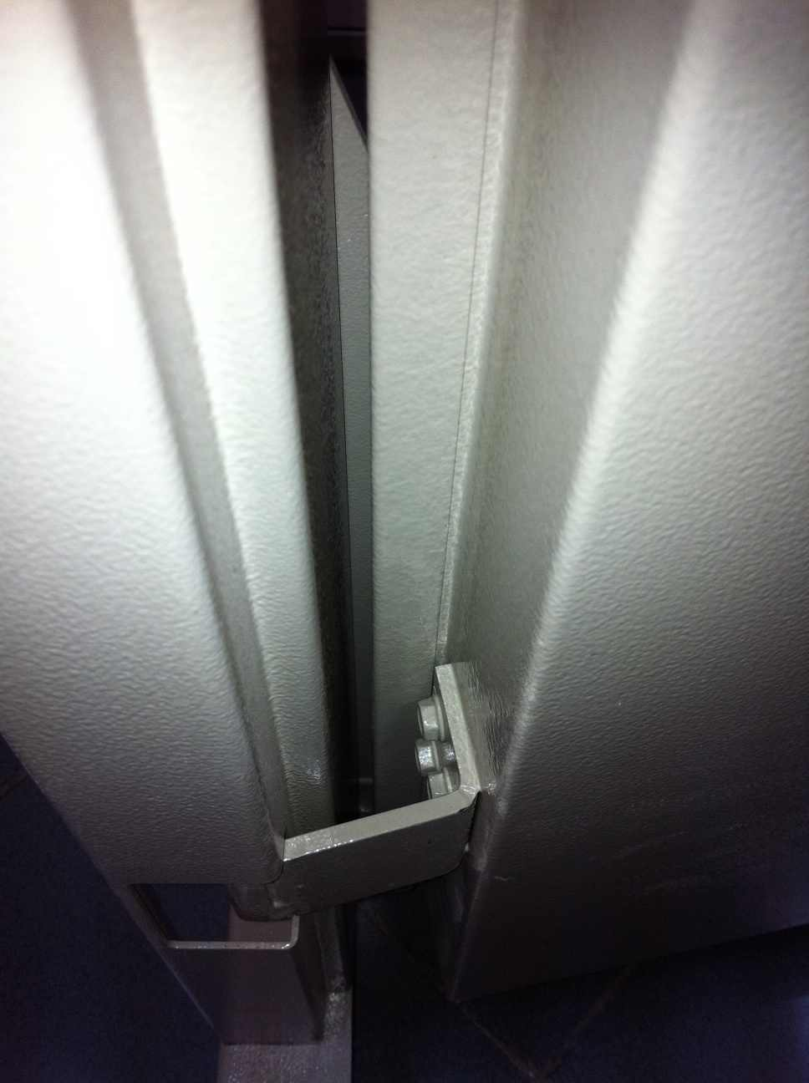 | 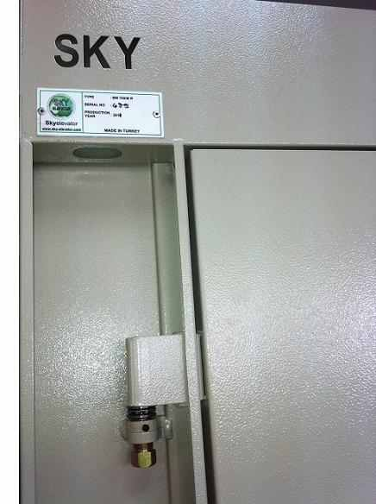 | 