SKY-G03
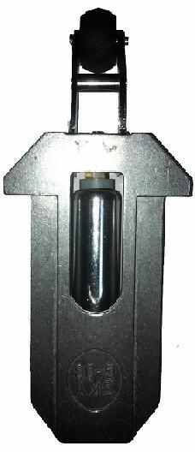 | 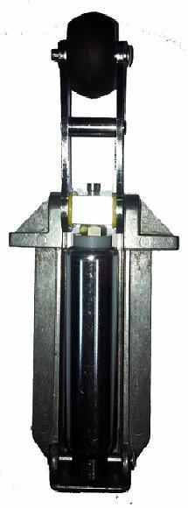
SKY-G03
Lift Landing Door Shock Absorber
» Special calibrated body,
» Grand piston in fine sizes corrosion resisting
» Chrome-Nickel-Plated piston pin,
» Minimal wear of the wheel due to friction
» Adjustment fixing bolt,
» Special packaging to protect against outer factors enabling easy storage
» Two year actual guarantee
Technical Drawing
