Sky 24*0,75mm
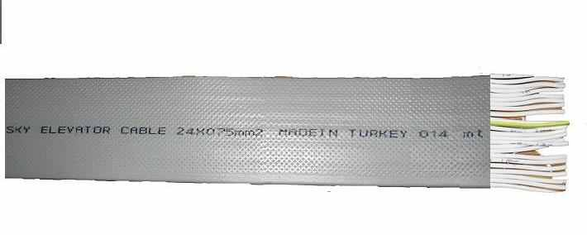
Annealed electrolytic flexible copper conductor, class 5 according to Iec 228.
PVC insulations (PVC/D type). Conductors of this cable have been identified by numbers.
Numerical markings appears at least 25 times per meter.
PVC outer sheath (pvc/ST5) black color.Conductors are white color.
Nylon rope for easy pulling of the outer sheath of this cable is optional.Nylon rope doesnot effect the price.
DIMENSIONS
Nominal Cross-Section | Width (mm) | Height (mm) | Weight (gr/m)
6x0.75 | 19 | 4.2 | 142
12x0.75 | 33.8 | 4.2 | 284
16x0.75 | 44.4 | 4.2 | 366
18x0.75 | 50.5 | 4.2 | 415
20x0.75 | 55 | 4.2 | 463
24x0.75 | 65.6 | 4.2 | 550
24x0.75 * | 70.4 | 4.2 | 642
12x1 | 36.2 | 4.4 | 330
16x1 | 47.6 | 4.4 | 445
20x1 | 59 | 4.4 | 545
24x1 | 70.4 | 4.4 | 620
24x1 * | 75.6 | 4.4

