SKYHS22



Technical Drawing

[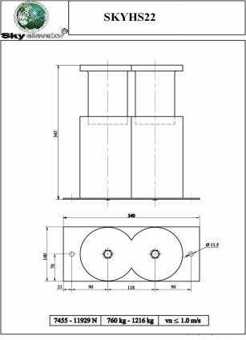](http://dapsan.com/uploads/iking.JPG)