SKYHS11

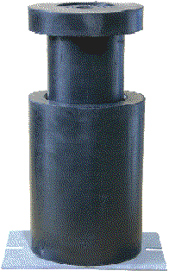

**Technical Drawing**

[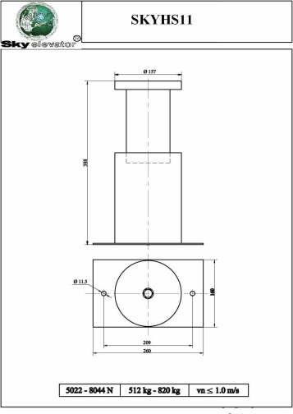](http://dapsan.com/uploads/skyhs11.JPG)