8003
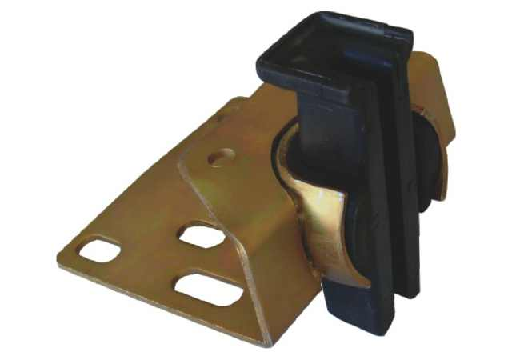
FEATURES
• 4 mm galvanized sheet
• Polyamide guide shoe
• Supported by rubber
• 3 types for guides 5-9-16m
• Work speed max 1.2m/sc
Technical Drawing
